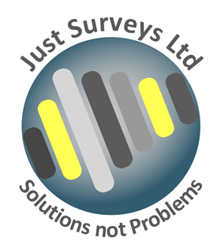
Quality Management Statement

Just Surveys Limited was established in 2006 to provide Drainage Services, both commercial and private. We are based in Gloucester. We invest time in recruiting and maintaining the right staff and encourage our team to invest in our business aims and objectives. We value the loyalty of our customers and ensure that our staff understand the importance of maintaining the high standard of customer care that we are recognised for throughout the industry.

Quality is important to our business because we value our customers. We strive to provide our customers with services which meet and even exceed their expectations.

We are committed to continuous improvement and have established a Quality Management System which provides a framework for measuring and improving our performance.

We have the following systems and procedures in place to support us in our aim of total customer satisfaction and continuous improvement throughout our business:

1. Regular gathering and monitoring of customer feedback
2. A customer complaints procedure
3. Selection and performance monitoring of suppliers against set criteria
4. Training and development for our employees
5. Regular audit of our internal processes
6. Measurable quality objectives which reflect our business aims
7. Management reviews of audit results, customer feedback and complaints

Our internal policies and procedures are reviewed regularly and are held in our staff handbook which is made available to all employees.

This policy is posted on the Company Notice Board and can also be found in the staff handbook.

Though the Managing Director has ultimate responsibility for Quality all employees have a responsibility within their own areas of work so helping to ensure that Quality is embedded within the whole of the company.

Signed
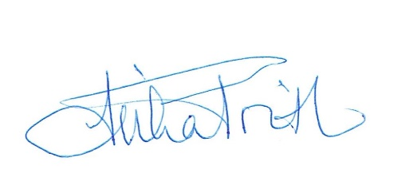
Reviewed 18/01/2024

